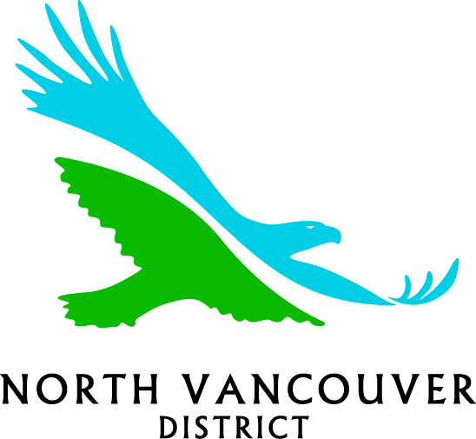

2016 CHILD CARE GRANTS PROGRAM
The District of North Vancouver is committed to being an active partner in the development and maintenance of a comprehensive child care system which encourages equitable access to affordable, quality programs for District families. The Child Care Grants Program promotes quality, availability and affordability of highly needed child care services.

WHAT KINDS OF PROJECTS ARE FUNDED?
Projects that enhance quality of care and address District priorities for child care, including development of innovative services or programs that can be used as models by other childcare providers. Maximum grants are up to $8,000.

WHAT ARE DISTRICT PRIORITIES?
Priority will be given to new or innovative proposals that address:
- Infant/toddler care
- Flexible and/or non-traditional hours of care
- School age child care (before and after school care) including care for 9-12 year olds
- Supported child care/Special Needs Care
- Supports to vulnerable families (not direct financial aid such as bursaries or subsidized care)
- Caregiver/parent education (priority will be given to organizations that are working collaboratively to serve multiple groups of parents and caregivers within a community)

WHO IS ELIGIBILE?
To be eligible for a 2016 District of North Vancouver Child Care Grant:
- The facility must be located in the District of North Vancouver or be a unique service on the North Shore serving District families.
- The organization must be a registered non-profit society in good standing with the Registrar of Companies for at least one year, or be sponsored by a registered non-profit society in good standing for at least one year.
- The organization must have a volunteer independent governing body.
- The organization must extend its services to the general public in the District and shall not exclude anyone by reason of race, religion or ethnic background
- The organization will not act as a funding body or make grants to any other groups or organization.
- When appropriate, organizations applying for larger grants, should be seen to be forming partnerships and seeking monies from other funding sources, or contributing their own funds (money or in-kind) to the project
- If the organization was previously funded, all accountability forms must have been submitted on time.

2016 GRANT PROCESS
Expressions of Interest will be reviewed by the Community Child Care Grants Committee for eligibility and fit with District priorities as outlined above. Organizations submitting proposals that meet these objectives will be contacted by the Committee to prepare a formal grant application.

The District of North Vancouver invites eligible groups to submit their proposal for enhancing child care services in the District by completing the Expression of Interest form and returning the form to the District by 4:30 p.m. on Monday, April 11, 2016. The form can be downloaded from the District’s website at www.dnv.org, following the pathway Live/Social Services/Childcare.

Got a good idea but not sure if it fits? Contact Cristina Rucci, Sustainable Community Planning Department at 604-990-2274 or crucci@dnv.org to discuss possibilities and eligibility

District of North Vancouver

2016 CHILD CARE GRANTS
EXPRESSION OF INTEREST

ORGANIZATION

CONTACT

ADDRESS

SITE ADDRESS

PHONE FAX E-MAIL

AMOUNT REQUESTED (approximately)

Briefly describe your proposed project and how it will fit with district childcare priorities
(please submit a separate expression of interest for each project)

SUBMIT TO: Cristina Rucci, Social Planner, Sustainable Community Planning Department, District of North Vancouver
355 West Queens Rd., North Vancouver, BC V7N 4N5
Fax: 604-984-8664 Email: crucci@dnv.org

DEADLINE: 4:30 P.M. Monday, April 11, 2016

Ongoing projects are also eligible for funding. Other projects that don’t fit district priorities but enhance quality of care will also be considered.

